**A REPORT ON**

# VOCATIONAL TRAINING AT

**VEDAM LABS**

SUBMITTED TO PUNYASHLOK AHILYADEVI HOLKAR UNIVERSITY, SOLAPUR

IN THE PARTIAL FULFILLMENT OF THE REQUIREMENTS FOR THE AWARD OF THE DEGREE OF

**BACHELOR OF ENGINEERING**

**(ELECTRONICS AND TELECOMMUNICATION ENGINEERING)**

**BY**

**Ms. ANKITA MAHESH SALUNKE .**

**Roll . No.: 36**



#### DEPARTMENT OF ELECTRONICS & TELECOMMUNICATION ENGINEERING

**SHRI A.P.D. JAIN PATHASHALA’S**

## WALCHAND INSTITUTE OF TECHNOLOGY

**SETH WALCHAND HIRACHAND MARG SOLAPUR 413 006 MAHARASHTRA**

OCT 2019

# CERTIFICATE

*This is to certify that the report entitled*

**VOCATIONAL TRAINING**

**AT**

# VEDAM LABS

*Submitted by*

**Ms. ANKITA MAHESH SALUNKE .**

*Is a bona fide work carried out by him/her under the supervision of* ***Dr. Ms. A. V. Thalange*** *and the training in charge at the company and it is approved for the partial fulfillment of the requirement of PAH Solapur University, Solapur for the award of the degree of*

***Bachelor of Engineering (Electronics and Telecommunication Engineering)***

*This work has not been earlier submitted to any Institute or University for the award of any degree or diploma.*

## Dr. Ms. A. V. Thalange Dr. R. R. Dube

Vocational Training Coordinator Head E&TC Dept.

## Dr. S. A. Halkude

Principle

**ACKNOWLEDGEMENT**

The vocational training has certainly enlightened us with the modern era of Technologies and it has boosted our confidence. The training work has certainly rendered us tremendous learning as well as practical experience.

We are thankful to **Dr. S. A. Halkude**, Principal, Walchand Institute of Technology, Solapur. **Dr. R. R. Dube**, Head of Electronics & Telecommunication Engineering Department for granting permission to undertake this training.

We are very grateful to **Dr. Ms. A. V. Thalange and Mr. Mohan Kondle**for their valuable guidance about hardware implementation and programming.

At last but not least we are thankful to staff of Electronics & Telecommunication Engineering Department Walchand Institute of Technology, Solapur.

**CONTENTS**

## CHAPTER - 1

## INTRODUCTION OF COMPANY…………………………………………….1

1.1 Introduction

1.2 Work carried out in the company

1.3 Customers of the company

1.4 Role in the Company

## CHAPTER – 2

## COMPANY DETAILS……………………………………………….2

## CHAPTER -3

## WHAT WE LEARNT? ………………………………………… …..5

1. Raspberry Pi
2. IoT
3. Image processing

#### INTRODUCTION OF COMPANY

#### 1.1 Introduction:

Vedam Labs is a proprietary company started in July 2014, with vision of developing enterprise applications and skilling engineering graduates. It provides Software, Hardware and Business solutions to the clients. Parallelly it bridge the gap between Industry and Colleges by training students and staff to reduce employability issues. It was founded by K. Mohan and M. Ashish in the year 2014. Today, Vedam Labs has its own Software and Hardware products. And has branches in three cities.

#### 1.2 Work carried out in the company:

1. Software Solution

Each business needs a stable enterprise software solution to support their operations. We have the experienced developers, latest tools, and technologies to create custom software as per client demands.

1. IOT Solution

Most enterprises or users need effective customized hardware solution to accumulate sensor data over cloud or to automate production process or simply control physical things remotely. With distinct knowledge and hands on experience, we serve all such industries or end user with solutions which include anything and everything from “Chip to Cloud”.

1. Business Solution

To explore emerging business needs we provide feasible solution to circumstances and help them envision their future. We Provide Analytical support which helps enterprise with better data relationships, uncovering insights and understanding the outcomes from AI solutions.

#### 1.3 Customers of the company:

1. UNIVERSAL, PUNE
2. Srt, Pune
3. BIT, Pune

**1.4 Role in the Company:** I was appointed as a trainee engineer.

#### COMPANY DETAILS:

#### Products and services provided by company:

**1.**Software solution:

The company experts will get the clients the affirmation of quality, feature-richness, design attributes and escalating overall application experience. With help of custom web app development team client will receive an application designed that specifically meet clients needs.

1. Web Solution:

Creative and feature-wealthy Web Application Development services at Vedam Labs allows clients to redefine your boundaries much wider in your industrial domain while help in approaching your business problems with a innovative approach .We have invested our years of acquaintance in developing out-of-box and user-centric custom Web application development solutions that help our clients in escalate their business as per their present and future demands.

Company always keep track of new technologies to deliver advanced software solutions, which Offers the crucial benefits of the latest technology, such as accessibility and highest security.

1. Mobile App:

The company will help you build robust mobile apps on a mobile platform with pre-built feature modules.

1. Native App Development-

Custom Mobile App Development services for leading app development platforms such as Android and iOS, allowing clients to reach a particular end-user base.

1. E-commerce Mobile App Development-

The rich E-commerce mobile app of the feature is helping the clients develop integrated shopping experience with different customization and enhanced mobile app development platforms for their users.

1. Hybrid App Development-

Experts developing the various solutions for the web applications in the native browser. The applications are developed via HTML, CSS and javascript.

c. Software Testing:

Software & application testing is treated to be crucial by enterprises all over the world. It is one such action that approves the functionality, performance, quality & other aspects of a software. But, with the ever expanding codebase and added functionality, manual testing is turning inefficient, tedious, laborious & costly day-by-day.

To overcome such issues, the company will automation testing, Which significantly automates the tasks and functions needed to increase their quality and effectiveness.

1. Embedded Solution:

In the past few decades, embedded systems have become an integral part of our daily lives. The embedded system fulfills the needs of customers like Transport, Electronic Applications, Mobility, Communication etc. The company offers full scope product design services in the embedded domain helping the clients to bring their ideas into live products.

1. IoT Solution:

Many enterprises attempts to effectively integrate and scrutinize large-scale sensor data on various sensors. Correlate huge data sets from various data sources and formats. Run analytical models to obtain relevant insights on traditional systems

* 1. Data acquisition-

Data acquisition from devices, sensors, and equipment using standard IoT protocols XMPP and MQTT.

* 1. Large scale data processing-

Large scale data processing and transformation using the agility and power of Big Data.

* 1. Analytics-

Edge Analytics to monitor and control connected devices.Real time analytics to view and generate insights, visualization and alerts.

* 1. Engines-

Data correlation engine to improve decision making by event correlation and rule processing Data analytics engine with use of parallel distributed processing of large sets of data in Big Data processing.

1. Business Solution:

Vedam Lab’s first priority is for collaborative innovation, clients will be able to engage with to explore their emerging business needs as we provide feasible solution to circumstances and help them envision their future

The company team is expertise to help clients:

* + - Explore new revolutionary trends
    - Create ideal solution and prototype them rapidly
    - Provide powerful new business models, services and products.
    - Build an enterprise-wide culture of ingenuity and innovation.
    - Explore ways to personalize your user experience.

## 3. WHAT WE LEARNT?

## 1. Raspberry Pi:

The **Raspberry Pi** is a series of small[single-](https://en.wikipedia.org/wiki/Single-board_computer)board computer[s](https://en.wikipedia.org/wiki/Single-board_computer)developed in the[UnitedKingdom](https://en.wikipedia.org/wiki/United_Kingdom)by the[Raspberry Pi Foundation](https://en.wikipedia.org/wiki/Raspberry_Pi_Foundation)to promote teaching of basic[computer science](https://en.wikipedia.org/wiki/Computer_science)in schools and in[developing countries](https://en.wikipedia.org/wiki/Developing_countries)

The raspberry pi comes in two models, they are model A and model B. The main difference between model A and model B is USB port. Model A board will consume less power and that does not include an Ethernet port. But, the model B board includes an Ethernet port and designed in china. The raspberry pi comes with a set of open source technologies, i.e. communication and multimedia web technologies. In the year 2014, the foundation of the raspberry pi board launched the computer module, that packages a model B raspberry pi board into module for use as a part of embedded systems, to encourage their use.

The raspberry pi comes in two models, they are model A and model B. The main difference between model A and model B is USB port. Model A board will consume less power and that does not include an Ethernet port. But, the model B board includes an Ethernet port and designed in china. The raspberry pi comes with a set of open source technologies, i.e. communication and multimedia web technologies. In the year 2014, the foundation of the raspberry pi board launched the computer module, that packages a model B raspberry pi board into module for use as a part of embedded systems, to encourage their use.

**Processor**

The Raspberry Pi 3 Model B uses a Broadcom BCM2837 SoC with a 1.2 GHz 64-bit quad-core[ARMCortex-A53](https://en.wikipedia.org/wiki/ARM_Cortex-A53)processor, with 512 KB shared L2 cache. The Model A+ and B+ are 1.4 GHz

**Performance**

The Raspberry Pi 3, with a quad-core[ARM Cortex-A53](https://en.wikipedia.org/wiki/ARM_Cortex-A53)processor, is described as having ten times the performance of a Raspberry Pi 1.[[41]](https://en.wikipedia.org/wiki/Raspberry_Pi#cite_note-:0-41)Benchmarks showed the Raspberry Pi 3 to be approximately 80% faster than the Raspberry Pi 2 in[parallelised](https://en.wikipedia.org/wiki/Parallel_computing)tasks.

**1.1 Hardware description of Raspberry Pi:**

Memory-

The raspberry pi model Aboard is designed with 256MB of SDRAM and model B is designed with 51MB.Raspberry pi is a small size PC compare with other PCs. The normal PCs RAM memory is available in gigabytes. But in raspberry pi board, the RAM memory is available more than 256MB or 512MB

CPU (Central Processing Unit)-

The Central processing unit is the brain of the raspberry pi board and that is responsible for carrying out the instructions of the computer through logical and mathematical operations. The raspberry pi uses ARM11 series processor, which has joined the ranks of the Samsung galaxy phone.

GPU (Graphics Processing Unit)-

The GPU is a specialized chip in the raspberry pi board and that is designed to speed up the operation of image calculations. This board designed with a Broadcom video core IV and it supports OpenGL

Ethernet Port-

The Ethernet port of the raspberry pi is the main gateway for communicating with additional devices. The raspberry pi Ethernet port is used to plug your home router to access the internet.

GPIO Pins-

The general purpose input & output pins are used in the raspberry pi to associate with the other electronic boards. These pins can accept input & output commands based on programming raspberry pi. The raspberry pi affords digital GPIO pins. These pins are used to connect other electronic components. For example, you can connect it to the temperature sensor to transmit digital data.

XBee Socket-

The XBee socket is used in raspberry pi board for the wireless communication purpose.

Power Source Connector

The power source cable is a small switch, which is placed on side of the shield. The main purpose of the power source connector is to enable an external power source.

UART-

The Universal Asynchronous Receiver/ Transmitter is a serial input & output port .That can be used to transfer the serial data in the form of text and it is useful for converting the debugging code.

Display-

The connection options of the raspberry pi board are two types such as HDMI and Composite. Many LCD and HD TV monitors can be attached using an HDMI male cable and with a low-cost adaptor. The versions of HDMI are 1.3 and 1.4 are supported and 1.4 version cable is recommended. The O/Ps of the Raspberry Pi audio and video through HMDI, but does not support HDMI I/p. Older TVs can be connected using composite video. When using a composite video connection, audio is available from the 3.5mm jack socket and can be sent to your TV. To send audio to your TV, you need a cable which adjusts from 3.5mm to double RCA connectors.

#### 1.2 Pin Diagram of Raspberry Pi:

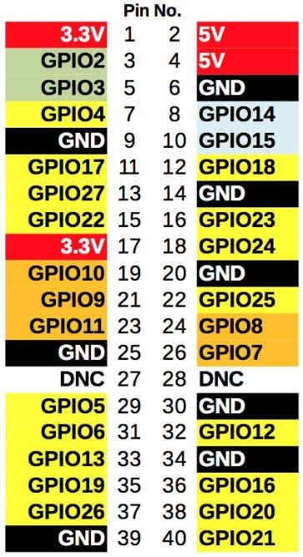

**2. Internet of Things (IoT):**

The internet of things, or IoT, is a system of interrelated computing devices, mechanical and digital machines, objects, animals or people that are provided with unique identifiers ([UIDs)](https://internetofthingsagenda.techtarget.com/definition/unique-identifier-UID) and the ability to transfer data over a network without requiring human-to-human or human-tocomputer interaction.

#### 2.1 How IoT works?

An IoT ecosystem consists of web-enabled smart devices that use embedded processors, sensors and communication hardware to collect, send and act on data they acquire from their environments.[IoT devices](https://internetofthingsagenda.techtarget.com/definition/IoT-device)share the sensor data they collect by connecting to an IoT gateway or other edge device where data is either sent to the cloud to be analyzed or analyzed locally. Sometimes, these devices communicate with other related devices and act on the information they get from one another. The devices do most of the work without human intervention, although people can interact with the devices -- for instance, to set them up, give them instructions or access the data. The connectivity, networking and communication protocols used with these web-enabled devices largely depend on the specific IoT applications deployed.

#### 2.2 Importance of IoT

The internet of things helps people live and work smarter as well as gain complete control over their lives. In addition to offering smart devices to automate homes, IoT is essential to business.

IoT provides businesses with a real-time look into how their companies’ systems really work, delivering insights into everything from the performance of machines to supply chain and logistics operations. IoT enables companies to automate processes and reduce labor costs. It also cuts down on waste and improves service delivery, making it less expensive to manufacture and deliver goods as well as offering transparency into customer transactions.

IoT touches every industry, including healthcare, finance, retail and manufacturing.[Smartcities](https://internetofthingsagenda.techtarget.com/definition/smart-city)help citizens reduce waste and energy consumption and connected sensors are even used in farming to help monitor crop and cattle yields and predict growth patterns. As such, IoT is one of the most important technologies of everyday life and it will continue to pick up steam as more businesses realize the potential of connected devices to keep them competitive.

### 2.3 Applications of IoT:

.

(

A

)

(

B) (C

)

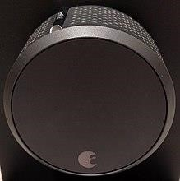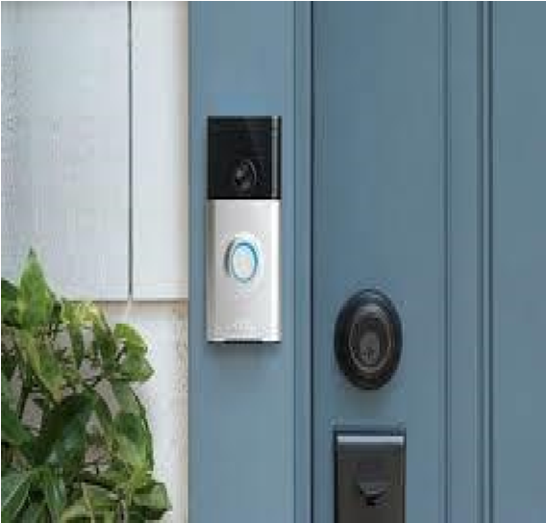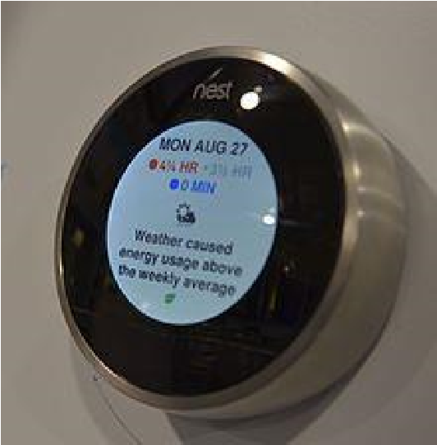

1. Smart thermostats are thermostats that can be used with home automation and are responsible for controlling a home's heating and/or air conditioning
2. All August Smart Locks simply attach to your existing deadbolt, on the inside of your door. Since it does not change the exterior of your lock your keys will still work. Works with your existing single-cylinder deadbolt. Installs in minutes on the inside of your door.
3. A smart doorbell is an internet-connected doorbell that notifies the smartphone or other electronic device of the home owner when a visitor arrives at the door. It activates when the visitor presses the button of the doorbell, or alternatively, when the doorbell senses a visitor with its built-in motion sensors.

#### Pros and cons of IoT:

Some of the advantages of IoT include:

* Ability to access information from anywhere at any time on any device;
* Improved communication between connected electronic devices

Some disadvantages of IoT include:

* As the number of connected devices increases and more information is shared between devices, the potential that a hacker could steal confidential information also increases;
* Enterprises may eventually have to deal with massive numbers -- maybe even millions -- of IoT devices and collecting and managing the data from all those devices will be challenging. •If there’s a bug in the system, it’s likely that every connected device will become corrupted.

## 3. Image Processing:

Digital Image Processing means processing digital image by means of a digital computer. We can also say that it is a use of computer algorithms, in order to get enhanced image either to extract some useful information.

#### 3.1 Image processing mainly include the following steps:

1. Importing the image via image acquisition tools;
2. Analysing and manipulating the image;
3. Output in which result can be altered image or a report which is based on analysing that image.

#### 3.2 What is an image?

An image is defined as a two-dimensional function, F**(x, y)** where x and y are spatial coordinates, and the amplitude of F at any pair of coordinates (x,y) is called the intensity of that image at that point. When x,y, and amplitude values of F are finite, we call it a digitalimage. In other words, an image can be defined by a two-dimensional array specifically arranged in rows and columns. Digital Image is composed of a finite number of elements, each of which elements have a particular value at a particular location.These elements are referred to as picture elements, image elements, and pixels. A Pixel is most widely used to denote the elements of a Digital Image.

#### Types of an image:

1. **BINARY IMAGE**– The binary image as its name suggests, contain only two pixel elements i.e 0 & 1, where 0 refers to black and 1 refers to white. This image is also known as Monochrome.
2. **BLACK AND WHITE IMAGE**– The image which consist of only black and white color is called BLACK AND WHITE IMAGE.
3. **8 bit COLOR FORMAT**– It is the most famous image format.It has 256 different shades of colors in it and commonly known as Grayscale Image. In this format, 0 stands for Black, and 255 stands for white, and 127 stands for gray.

**4.Tasks Performed By Trainee Engineer**

#### 4.1 Software Used: Spyder

#### 4.2 Image Processing:

* [Changing Colorspaces](https://opencv-python-tutroals.readthedocs.io/en/latest/py_tutorials/py_imgproc/py_colorspaces/py_colorspaces.html#converting-colorspaces)
* [Geometric Transformations of Images](https://opencv-python-tutroals.readthedocs.io/en/latest/py_tutorials/py_imgproc/py_geometric_transformations/py_geometric_transformations.html#geometric-transformations)
* [Image Thresholding](https://opencv-python-tutroals.readthedocs.io/en/latest/py_tutorials/py_imgproc/py_thresholding/py_thresholding.html#thresholding)
* [Smoothing Images](https://opencv-python-tutroals.readthedocs.io/en/latest/py_tutorials/py_imgproc/py_filtering/py_filtering.html#filtering)
* [Morphological Transformations](https://opencv-python-tutroals.readthedocs.io/en/latest/py_tutorials/py_imgproc/py_morphological_ops/py_morphological_ops.html#morphological-ops)
* [Image Gradients](https://opencv-python-tutroals.readthedocs.io/en/latest/py_tutorials/py_imgproc/py_gradients/py_gradients.html#gradients)
* [Canny Edge Detection](https://opencv-python-tutroals.readthedocs.io/en/latest/py_tutorials/py_imgproc/py_canny/py_canny.html#canny)
* [Image Transforms in OpenCV](https://opencv-python-tutroals.readthedocs.io/en/latest/py_tutorials/py_imgproc/py_transforms/py_table_of_contents_transforms/py_table_of_contents_transforms.html#table-of-content-transforms)
* [Template Matching](https://opencv-python-tutroals.readthedocs.io/en/latest/py_tutorials/py_imgproc/py_template_matching/py_template_matching.html#template-matching)

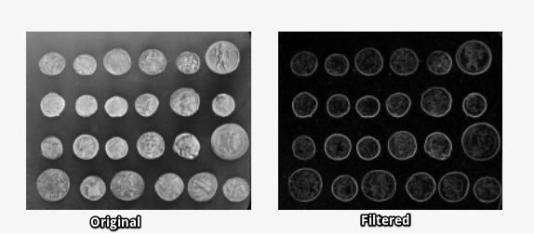

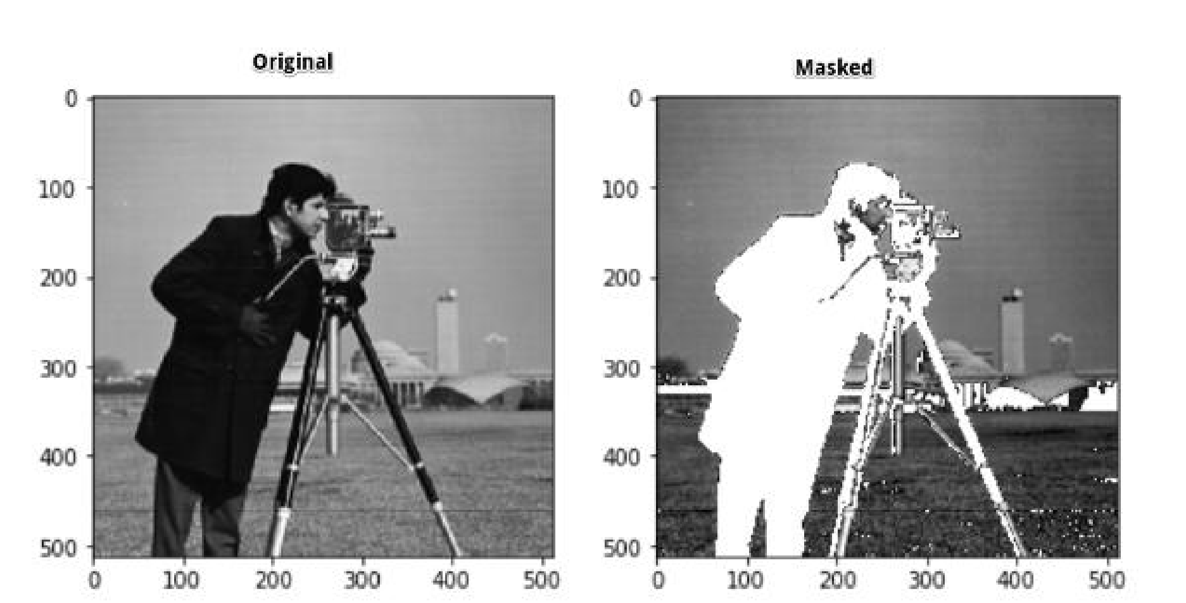

**4.3 IoT:**

We had hands-on experience on raspberry pi which we used using python language, raspberry is a versatile device which performs several functions one of it was GPS, we were able to locate our latitude and longitude with the help on GPS, another function of it was RFiD, in which we created a separate identity for the user with the help of RFiD which was only accessible to the user.

## Name of Student: Ms. Ankita Mahesh Salunke

Class: B.E.(E&TC-Regular) Year :2019-20

## Duration of Training: 1stJune to 15thJune 2018

|  |  |
| --- | --- |
| Company Name | Vedam labs |
| Address | Akkalkot road , solapur |
| Pin code | 416006 |
| Phone No | 0217-2655516 |
| Mobile no . | 7719977818 |
| Website | www.vedamlab.com |
| Company sector | Electrical Equipments And IT Solutions |
| Incorporation sector | Pvt.Ltd |